
Work Instruction for Adding ASM Disks in Physical Server

Viatris
Work Instruction for Adding ASM Disks in Physical Server

Contents
Contents 2
1. Introduction 4
1.1. Purpose 4
1.2. Scope of this Report 4
1.3. Audience 4
2. Approach and Methodology 4
2.1. Approach 4
2.1.1. Capacity growth check 4
2.1.2. Create a Change Request 4
2.1.3. Coordinate with the Storage Team 4
2.1.4. Scan for Newly Added Disks 4
2.1.5. Backup Existing ASM Configuration Rules 4
2.1.6. Partition the New Disks 4
2.1.7. Update ASM Rules 5
2.1.8. Reload ASM Rules 5
2.1.9. Verify Disk Visibility in ASM 5
2.1.10. Confirm Change Approval 5
2.2. Methodology 5
2.2.1. Planning and Preparation 5
2.2.2. Pre-Implementation Validation 5
2.2.3. Disk Configuration 5
2.2.4. Post-Implementation Validation 6
2.2.5. Documentation and Compliance 6
2.2.6. Rollback Plan 6
3. Technical Details 6
3.1. Scan for the newly added disk 6
3.2. Backup Existing ASM Configuration Rules 7
3.3. Partition the New Disks 7
3.4. Find the UUID (Universally Unique Identifier) for the block device 8
3.5. Update ASM Rules 8
3.6. Reload ASM Rules 8
3.7. Verify Disk Visibility in ASM 8
4. Roles and Responsibilities 9
5. Escalation Matrix 9
6. Revision History 9

1. Introduction

1.1. Purpose
This document outlines the procedure for adding ASM disks to a physical server based on business requirements

1.2. Scope of this Report
This guide provides detailed steps for adding ASM disks to a physical server, including pre-validation, configuration, and post-implementation checks.

1.3. Audience
GIDC UNIX Group

2. Approach and Methodology

Approach
This section provides a high-level overview of the steps required to add ASM disks to a physical server:
- Check server capacity growth and obtain necessary approvals.
- Create a Change Request (CR) in ServiceNow.
- Coordinate with the Storage team to allocate the required disks.
- Scan for newly added disks and verify their sizes.
- Backup existing ASM configuration rules.
- Partition the new disks.
- Update ASM rules for the new disks.
- Reload ASM rules.
- Verify disk visibility in the ASM disk group.
- Confirm change approval before implementation.

Methodology

2.2.1. Planning and Preparation
- Change Request (CR): Create and document a CR in ServiceNow with all relevant details and obtain necessary approvals.
- Storage Team Coordination:
  - Share the requirements with the Storage team, including disk specifications and server details.
  - Confirm the timeline for disk allocation.

2.2.2. Pre-Implementation Validation

Disk Availability:

Scan for the newly allocated disks and verify their sizes using tools such as lsblk or fdisk -l.

Backup Configuration:

Back up the existing ASM configuration rules in /etc/udev/rules.d to enable easy rollback if required.

2.2.3. Disk Configuration
Partition the Disks:
- Use partitioning tools such as fdisk or parted to create the required partitions for ASM.
Update ASM Rules:
- Modify the /etc/udev/rules.d/<ASM Rules> file to include the new disks, ensuring correct ownership, permissions, and device naming.
- Apply Changes:
Reload the udev rules using the following commands:
#udevadm control --reload-rules
#udevadm trigger.

2.2.4. Post-Implementation Validation
- Log Review:
Check ASM and system logs for any warnings or errors related to the newly added disks.

2.2.5. Documentation and Compliance
1. Document the implementation process, including detailed steps, commands, and screenshots where applicable.
2. Ensure compliance with organizational change management and auditing requirements.

2.2.6. Rollback Plan

Maintain a clear rollback plan, using the backups of the ASM configuration and removing the newly added disks if needed.

Technical Details

Scan for the newly added disk
- Log in to the server using your MID and password, switch to the root user with sudo su -, and run the following command to verify that the newly added disks from the storage are visible on the server:"

# for i in `ls /sys/class/scsi_host/` ;do echo "=====Scanning SCSI host controller $i===";echo "- - -" > /sys/class/scsi_host/$i/scan
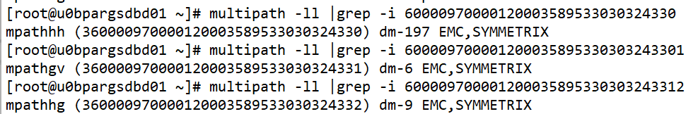

- Run the multipath -ll <LUN_ID> command to check the details of the LUN. Replace <LUN_ID> with the actual LUN ID

- Use lsblk to list all block devices along with their sizes.
- Use fdisk -l <Block_Device> to verify the details of a specific disk

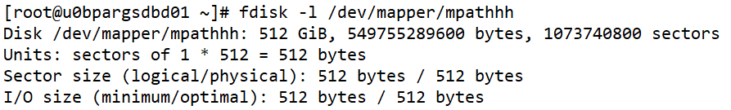

Backup Existing ASM Configuration Rules
- Take a backup of the ASM configuration file /etc/udev/rules.d/99-oracle-asmdevices.rules:

# cp /etc/udev/rules.d/99-oracle-asmdevices.rules /etc/udev/rules.d/99-oracle-asmdevices.rules_bkp_`date +'%d%m%Y'`

Partition the New Disks
- Once the new disk has been added create the partition

# fdisk [block device]
· To Create a new partition Press n and press Enter
· Choose primary partition by type p and press Enter.
· Choose Partition number by type 1 and press Enter
· Choose Partition cylinders start value as default and press Enter
· Choose Partition cylinders end value as default and press Enter
· Change the partition type by type t and press Enter
· Choose partition number by type 1 and press Enter
· View the partition table by type 'p' and press Enter
· Save the Partition table by type 'w' and press Enter

Find the UUID (Universally Unique Identifier) for the block device
- /usr/lib/udev/scsi_id -u -g -d [block device]

Update ASM Rules
- Open the ASM rules file and add an entry for the new disk using the UUID obtained in the previous step:

# vi /etc/udev/rules.d/99-oracle-asmdevices.rules
ACTION=="add|change", ENV{DM_UUID}=="part1-mpath-<UUID(LUN_ID)>", SYMLINK+="<ASM DISK Name>", GROUP="asmadmin", OWNER="grid", MODE="0660"
Note: Collect the UID ids and update above configuration as well us ASM Disk Name from the Change Request Work Notes

Reload ASM Rules
- Reload the udev rule and update in the kernel

# udevadm control --reload-rule
# udevadm trigger --type=devices --action=change

Verify Disk Visibility in ASM
- Validate the newly created ASM disks using the following command:

# ls – l /dev/asm*

Roles and Responsibilities
Sl. no. | Roles | Responsibilities | Team Member Name
1. | Change Request | Respective Team / Unix Team | GIDC.unix_Run  GIDC.unix_Run@viatris.com
2. | Change Implementation | Respective Team / Unix Team | GIDC.unix_Run  GIDC.unix_Run@viatris.com

Escalation Matrix
Person Responsible | Role | Triggers When
Arun R  Arun.R@viatris.com  +91 9710677240 | Deputy Manager
Ashok Kumar R K  Ashokkumar.RK@viatris.com  +91 9967735890 | Senior Manager
Zahir Hussain M zahirhussain.M@viatris.com  +91 9840689462 | Senior Manager

6. Revision History

Date | Version | Summary of Changes | Author | Approved by
April 28 2025 | V1.0 | Created the Document | Benesh Selva Nesan P | Arun R
April 28 2026 | V1.1 | Validated the Document | Benesh Selva Nesan P | Arun R

